**East West University**

**Department of CSE**

**Lab Report 02**

**CSE 453**

**Wireless Networking**

**Submitted To:**

Md. Mahir Ashhab

Lecturer

Department of Computer Science and Engineering

**Submitted By:**

Adri Saha

ID: 2019-1-60-024

Submission Date: 11 August 2022

Planning Terrestrial Radio Networks

Part 2

**Providing my solutions:**

1. **Antenna height, type and orientation for each transmitter and receiver.**

**Ans:** Here, A, B = transmitter & C, D = receiver

Antenna gain: 13dBi for all.

**For A**, antenna type: yagi.ant

Antenna height: 100 meters

Orientation: A to D

**For B**, antenna type: yagi.ant

Antenna height: 100 meters

Orientation: B to C

**For C**, antenna type: yagi.ant

Antenna height: 25 meters

Orientation: C to B

**For D**, antenna type: yagi.ant

Antenna height: 25 meters

Orientation: D to A

1. **EIRP for each transmitter.**

**Ans:** A & B is transmitter.

**We know**, EIRP= Pt- LC +GA

Pt= transmitted power

Lc= Line loss

Ga= Antenna gain

**For A,**

**EIRPA (dBm)**= Pt- LC +GA

= 46.99-2+13

= 57.99 dBm = 58 dBm

**EIRPA (KW)** = (10^ (58/10))/1000 W = 630.957 W

= 0.630 KW

Which is same as the result we saw from the output EIRP screenshot below.

**For B,**

**EIRPB (dBm)**= Pt- LC +GA

= 46.99-5+13

= 54.99 dBm = 55 dBm

**EIRPB (KW)**= (10^ (55/10))/1000 W = 316.227 W

= 0.316 KW

Which is same as the result we saw from the output EIRP screenshot below.

1. **Numerically show that SIR is greater than 10dB at both receivers. Note that you do not need to calculate the received powers analytically in order to do this task. Simply use the signal and interference levels that you obtained in your simulation results. Also, be careful about the units when you calculate the signal-to-interference ratio.**

**Ans:**

From our results of radio link we saw,

From A to D Rx level is: -72 dBm

And B to D Rx level is: -93 dBm

**B is interference on AD.**

AD= AD-BD= -72.1-(93.7) =21.6 >10

**Again,**

From B to C Rx level is: -101 dBm

And A to C Rx level is: -112.3 dBm

**A is interference on BC.**

BC= BC-AC= -101-(-112.3) =11.3 >10

So, we see the signal to interference ratio, SIR for both AD and BC is 21.6 dB and 11.3 which is greater than 10dB. [showed]

1. **Briefly explain your solution method and results. In your explanation, use the screenshots of Radio Link profiles of both links and Interference plots at both receivers.**

**Ans:** Solution method steps are given below:

* First open network-ex-interf.net
* Then go to new picture, click on grayscale slope and draw
* Check show network—all

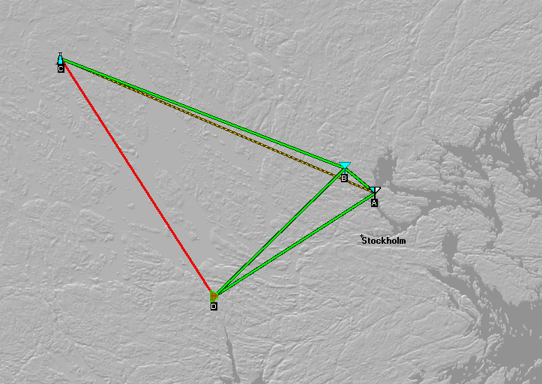

* Then go to the network properties and parameters.
* Make net name: data net, polarization: vertical, mode of variability: broadcast, additional loss, forest: 20%

* Now go to the systems & make 4 nodes named: node A, node B (for transmitter), node C, node D (for receiver)
* Here, some default parameters for all nodes:

Transmit power= 50 Watt

Receiver threshold= 0.7 uV

Line loss= 2dB

Antenna type= yagi.ant

* Now make some changes on antenna height.

Make node A, B height 100 meter

& C, D height 25 meter.

* Then go to the membership & click list of all units: A, B, C, D.
* Set the orientations for each nodes means change the antenna direction.
* Then go to the tools--- radio link.
* Check A to D, A to C, B to C, B to D. Here we can see some solutions like: Tx and Rx power, line loss, antenna gain, EIRP.

Radio link profiles screenshots are given:

* Then go to tools—radio coverage—interference
* Here, first draw for Tx unit A and Rx unit D. Between A and D interference is Tx unit B. Then draw the plot.

**Resulting plot:**

We see A to D there is green plot shows that required S/I has met.

* Now again draw new picture and go to interference radio coverage.
* Draw for Tx unit B and Rx unit C. Between B and C interference is Tx unit A. Then draw the plot.

**Resulting plot:**

We see B to C the green plot is the coverage area shows that required S/I has met.